**COGNIZANT JAVA FSE WEEK 1 OUTPUT**

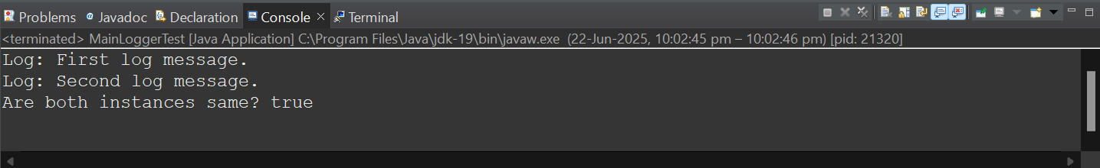**1.SINGLETON PATTERN OUTPUT**

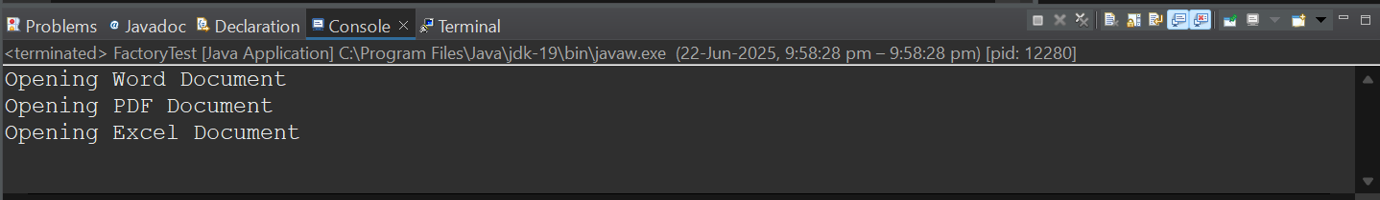**2.FACTOR METHOD OUTPUT**

**3.ECOMMERCE SEARCH**

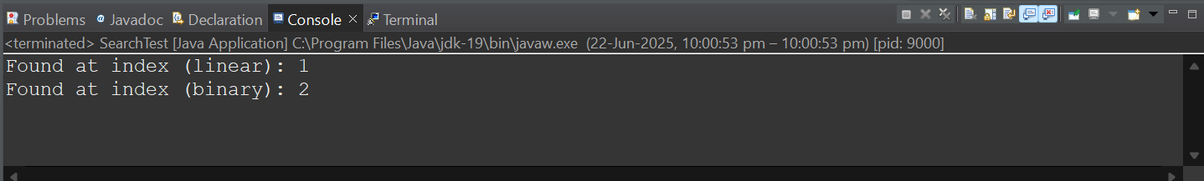

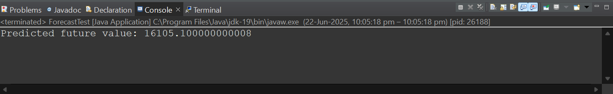**4.FINANCIAL FORECASTING**